CO4 ASSESSMENT TOOL 1 CODE CHALLENGE

CSA0652-Design and Analysis of Algorithms for Complexity Analysis.

DONE BY:
Name: J.VVINAY KAILASH A.M
Reg No: 192424062
SIMATS Engineering

Supervisor:
Dr. MARY HARIN FERNANDEZ , Professor
Dr. S. PRADEEP KUMAR, Professor

Question 1: Unbounded Knapsack

Source Code (unbounded_knapsack.py)
def unbounded_knapsack(W, weights, values, n):
dp = [0] * (W + 1)

for i in range(W + 1):
for j in range(n):
if weights[j] <= i:
dp[i] = max(dp[i], dp[i - weights[j]] + values[j])

return dp[W]

n = 3
values = [10, 30, 20]
weights = [5, 10, 15]
W = 100

result = unbounded_knapsack(W, weights, values, n)

print("Maximum Profit =", result)
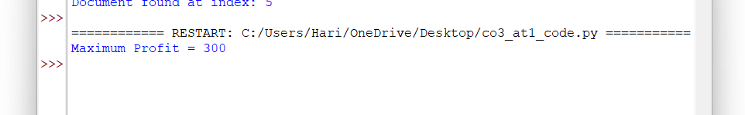
Output

Report
Title:
Unbounded Knapsack Using Dynamic Programming
Problem Analysis
A manufacturing unit produces different types of items. Each item can be used multiple times without any restriction. The objective is to maximize the total profit while ensuring that the total weight does not exceed the given capacity.
Requirements
- Multiple uses of the same item are allowed.
- Total weight must not exceed the capacity.
- Maximum profit should be obtained.
- Efficient computation for larger capacities.
Dynamic Programming Approach
- Create a DP array of size W + 1.
- Initialize all values to 0.
- For every capacity from 0 to W:
  - Check all items.
  - If the item weight is less than or equal to the current capacity, update the profit.
- Store the maximum profit for each capacity.
- The last element of the DP array gives the optimal solution.
Time Complexity
- Time Complexity: O(n × W)
- Space Complexity: O(W)
Result
For the given input:
- Values = {10, 30, 20}
- Weights = {5, 10, 15}
- Capacity = 100
Maximum Profit = 300

Question 2: Decode Ways Problem

Source Code (decode_ways.py)
def num_decodings(s):
if not s or s[0] == '0':
return 0

n = len(s)

dp = [0] * (n + 1)
dp[0] = 1
dp[1] = 1

for i in range(2, n + 1):
one_digit = int(s[i - 1:i])

if 1 <= one_digit <= 9:
dp[i] += dp[i - 1]

two_digits = int(s[i - 2:i])

if 10 <= two_digits <= 26:
dp[i] += dp[i - 2]

return dp[n]

s = "226"

print("Ways =", num_decodings(s))
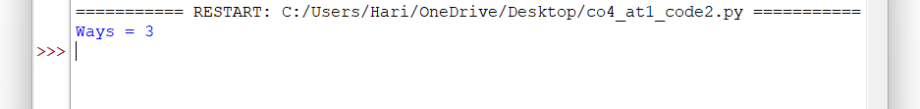
Output:

Report
Title:
Decode Ways Problem Using Dynamic Programming
Problem Analysis
A string of digits represents encoded letters where numbers from 1 to 26 correspond to letters A to Z. The objective is to determine the number of valid ways in which the given digit string can be decoded.
Requirements
- Digits from 1 to 26 represent valid characters.
- Invalid combinations must be ignored.
- All possible decoding combinations must be counted.
- Efficient computation is required for long strings.
Dynamic Programming Approach
- Create a DP array where dp[i] stores the number of ways to decode the first i characters.
- Initialize base cases.
- Check single-digit decoding possibilities.
- Check two-digit decoding possibilities.
- Update the DP array accordingly.
- The final DP value gives the total number of decoding ways.
Time Complexity
- Time Complexity: O(n)
- Space Complexity: O(n)
Result
For the given input:
- s = "226"
Possible Decodings:
- 2, 2, 6 → BBF
- 22, 6 → VF
- 2, 26 → BZ

Total Ways = 3

